**Question 1**

**Part a.**

function BondPrice = intensitybased_bondPricing(Time, volatility, reversion_rate)

T=Time;

sigma = volatility;

a = reversion_rate;

N = 250;

dt = T/N;

Xo = -0.01;

r= 0.04;

numlevels = 250;

M = a*dt;

dX =sigma * sqrt(3*dt);

jmax = ceil(0.184/M); jmin = -jmax; % jmax = 2; jmin = -jmax;

maxnodes = length(jmax:-1:jmin);

for k= numlevels-1:-1:0

Level = k+1;

numnodes = 2*k+1;

jTop = (numnodes-1)/2;

jBot = -jTop ;

Jarray = jTop:-1:jBot;

jLength = (jTop - jBot)+1;

for j= jLength:-1:1

X(j, Level) = Xo + Jarray(j)*dX;

lamda(j, Level) = 0.05*exp(X(j,Level));

lamda_dt = lamda(j,Level)*dt;

default_prob(j, Level) = lamda_dt;

%prob calculation

if ( Jarray(j) > jmax)

pu = (7/6) + (1/2)*((a^2)*(Jarray(j)^2)*(dt^2) - 3*a*Jarray(j)*dt);

pm = (-1/3) -( (a^2)*(Jarray(j)^2)*(dt^2)) + (2*a*Jarray(j)*dt);

pd = (1/6) + (1/2)*((a^2)*(Jarray(j)^2)*(dt^2) - (a*Jarray(j)*dt));

elseif ( Jarray(j) < jmin)

pu = (1/6) + (1/2)*((a^2)*(Jarray(j)^2)*(dt^2) + (a*Jarray(j)*dt));

pm = (-1/3) -( (a^2)*(Jarray(j)^2)*(dt^2)) - (2*a*Jarray(j)*dt);

pd = (7/6) + (1/2)*((a^2)*(Jarray(j)^2)*(dt^2) + 3*a*Jarray(j)*dt);

else

pu = (1/6) + (1/2)*((a^2)*(Jarray(j)^2)*(dt^2) - (a*Jarray(j)*dt));

pm = (2/3) - ((a^2)*(Jarray(j)^2)*(dt^2));

pd = (1/6) + (1/2)*((a^2)*(Jarray(j)^2)*(dt^2) + (a*Jarray(j)*dt));

end

if ( k==numlevels-1)

V(j, Level) = 1;

else

V(j,Level) = (exp(-r*dt))*((1-lamda_dt )*( (pu*V(j+1, Level+1)) + (pm*V(j+1, Level+1)) + (pd*V(j+1, Level+1)) ));

end

end

end

BondPrice = V(1,1);

**Part b.**

BP_risky=zeros(1,15);

BP_riskfree=zeros(1,15);

N= 1:15;

for k=1:15

BP_risky(:,k)= intensitybased_bondPricing(k, 2, 4);

BP_riskfree(:,k)=exp(-0.04*k);

end

BP_chart(1,:)=BP_risky;

BP_chart(2,:)=BP_riskfree;

BP_chart;

plot(N,BP_chart);

xlabel('Time to Maturity');

ylabel('Bond Price');

title('Bond Pice vs Time to Maturity');

legend('Bond Price - Defaultable', 'Bond Price - Default free')

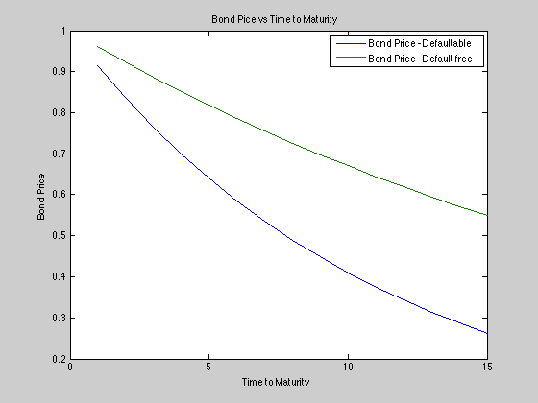

**Part c**

NumberOfYears = 15;

yieldSpread=zeros(1,NumberOfYears);

N=1:NumberOfYears;

for k=1:NumberOfYears

yieldBond = (1/k)*log(intensitybased_bondPricing(k, 2, 4));

yieldRiskFree = (-1/k)*log(exp(-0.04*k));

yieldSpread(:,k)= yieldBond - yieldRiskFree;

end

plot(N,yieldSpread);

xlabel('Time to Maturity');

ylabel('Yield Spread');

title('Yield Spread Curve');

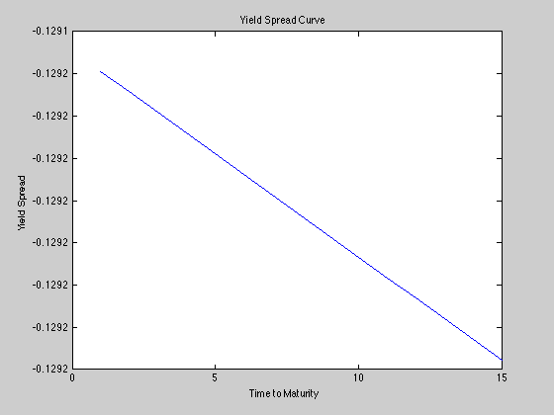

**Part d.**

Shape of the yield curve did not vary with volatility or rate of mean reversion since the yield spread is essentially lambda and it is a constant.

$$Y\left(T\right)= -\frac{1}{T}logP_{D}\left(T\right)-\left(-\frac{1}{T}\log\left(e^{-rT}\right)\right)= λ$$